|  |  |
| --- | --- |
|  | LAB 2: Understanding of TCP(Transmission Control Protocol) using wireshark and netsim. |
|  |  |
|  | Akshar Panchani ID- 202101522  IT304 Computer Networks  8/22/23 |

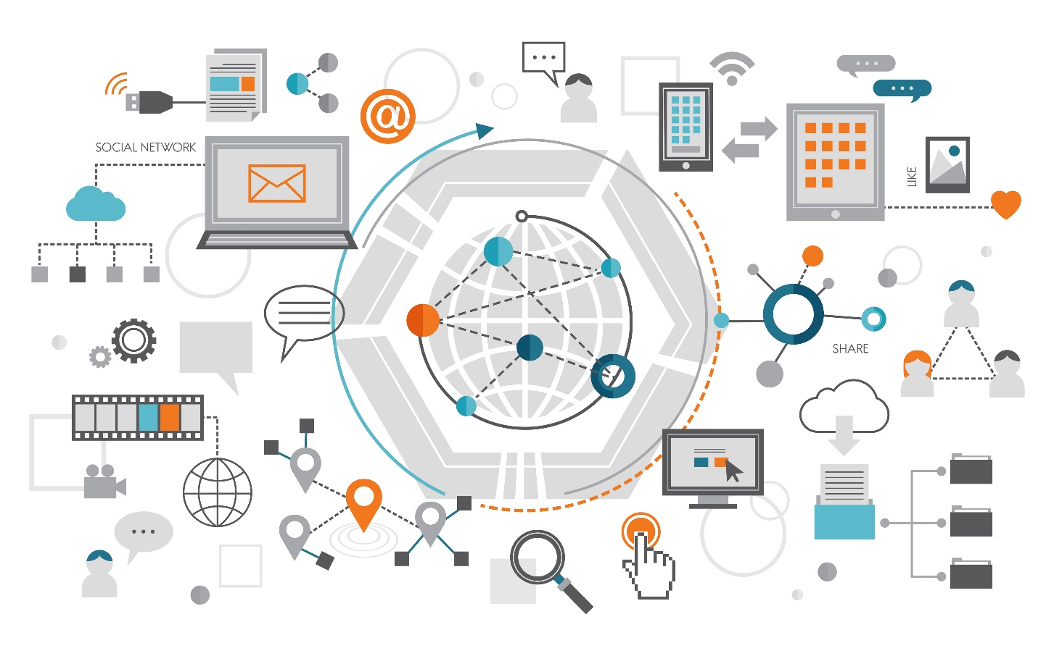

**Exercise:**

**1.2:**

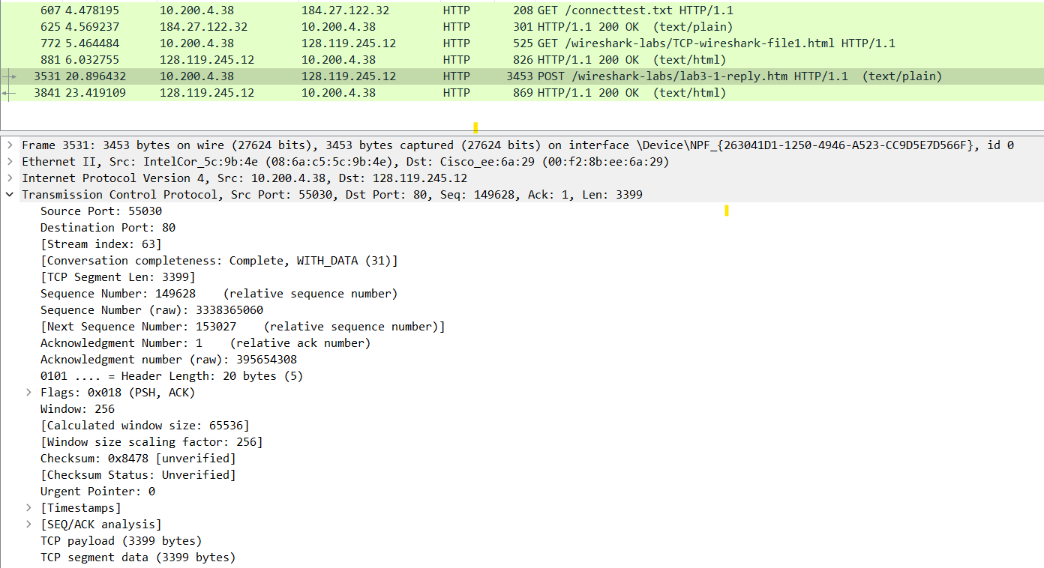

Answer below is based on this image reference .

1.What is the IP address and TCP port number used by the client computer (source) that is transferring the file to gaia.cs.umass.edu? To answer this question, it’s probably easiest to select an HTTP message and explore the details of the TCP packet used to carry this HTTP message, using the “details of the selected packet header window”.

IP address of client = 10.200.4.38

Port number of client = 55030

2. What is the IP address of gaia.cs.umass.edu? On what port number is it sending and receiving TCP segments for this connection?

IP address of server = 128.119.245.12

Port number of server = 80

3. What is the IP address and TCP port number used by your client computer (source) to transfer the file to gaia.cs.umass.edu?

Same as Q1 IP address and port number is same that is:

IP address of client = 10.200.4.38 and Port number of client = 55030

**2.2:**

1. What is the sequence number of the TCP SYN segment that is used to initiate the TCP connection between the client computer and gaia.cs.umass.edu? What is it in the segment that identifies the segment as a SYN segment?

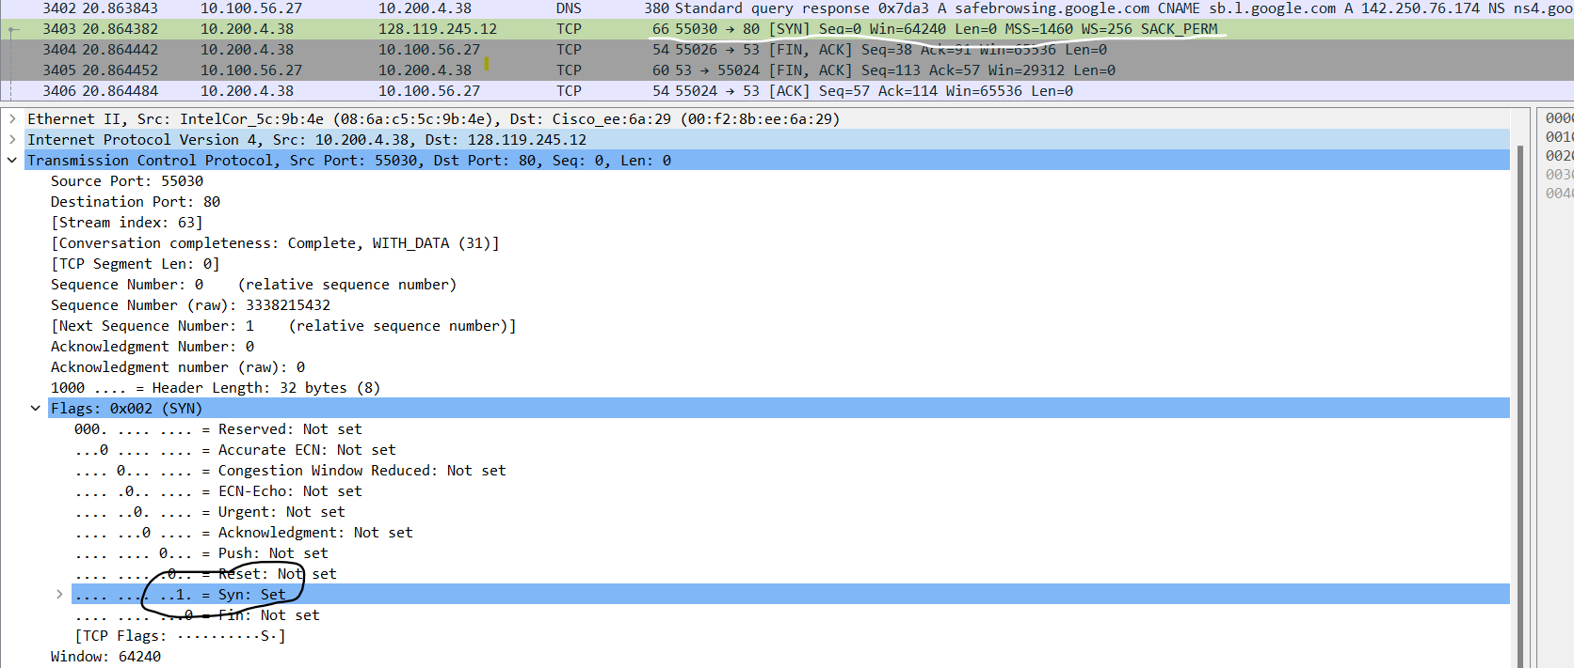

Sequence number of TCP SYN: 0

SYN segment which is flag as: 1 as Set

2. What is the sequence number of the SYNACK segment sent by gaia.cs.umass.edu to the client computer in reply to the SYN? What is the value of the Acknowledgement field in the SYNACK segment? How did gaia.cs.umass.edu determine that value? What is it in the segment that identifies the segment as a SYNACK segment?

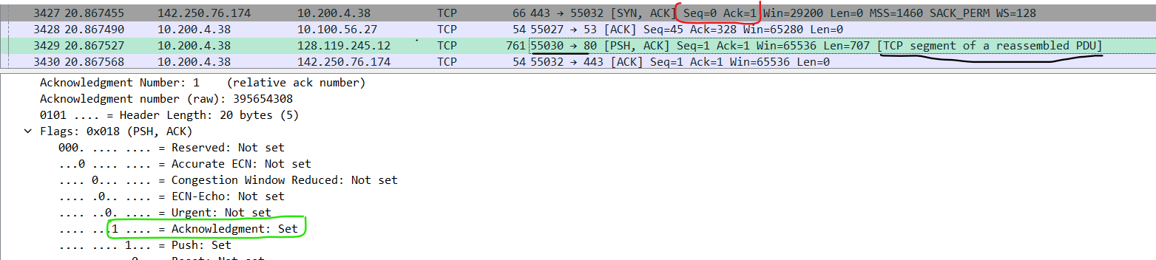

Seq Number of SYNACK in reply to SYN: 0

Value of Acknowledgement of SYNACK: 1

The site determine value by Seq number SYN segment + 1, which is 0 + 1

Here TCP is SYNACK as Acknowledgement is set to 1.

3. What is the sequence number of the TCP segment containing the HTTP POST command? Note that in order to find the POST command, you’ll need to dig into the packet content field at the bottom of the Wireshark window, looking for a segment with a “POST” within its DATA field.

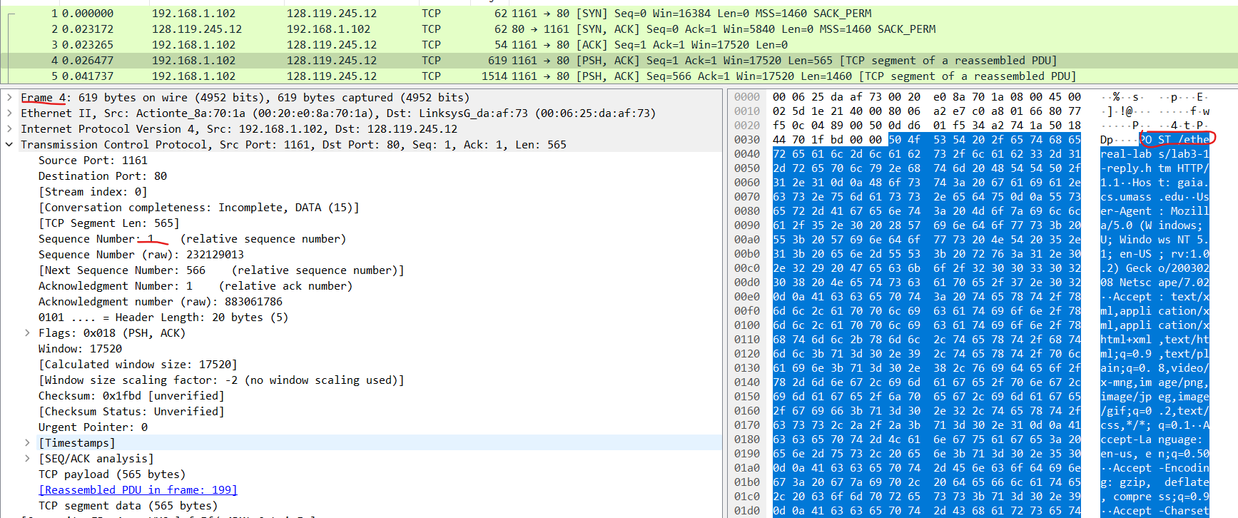

Seq Number is 1. Which is relative and the frame no is 4.

4. Consider the TCP segment containing the HTTP POST as the first segment in the TCP connection. What are the sequence numbers of the first six segments in the TCP connection (including the segment containing the HTTP POST)? At what time was each segment sent? When was the ACK for each segment received? Given the difference between when each TCP segment was sent, and when its acknowledgement was received, what is the RTT value for each of the six segments? What is the Estimated RTT value after the receipt of each ACK? Assume that the value of the Estimated RTT is equal to the measured RTT for the first segment.

Six Segment:

Segment 1 Seq no. is :1

Segment 2 Seq no. is :2026

Segment 3 Seq no. is :3486

Segment 4 Seq no. is :4946

Segment 5 Seq no. is :6406

Segment 6 Seq no. is :7866

Time:

Segment 1: 0.077924 s

Segment 2: 0.077924 s

Segment 3: 0.088034 s

Segment 4: 0.089023 s

Segment 5: 0.169105 s

Segment 6: 0.267801 s

Ack for each received :

Segment 1: 0.054026000 seconds

Segment 2: 0.054027000 seconds

Segment 3: 0.054027000 seconds

Segment 4: 0.054127100 seconds

Segment 5: 0.054128600 seconds

Segment 6: 0.054128600 seconds

RTT value :

Segment 1: 0.023265000 s

Segment 2: 0.023265000 s

Segment 3: 0.023265000 s

Segment 4: 0.023265000 s

Segment 5: 0.023266000 s

Segment 6: 0.023266000 s

5. What is the length of each of the first six TCP segments?

Length of the TCP segment is given as 707 bytes.

Length of each TCP segment: 1460 bytes (MSS).

6. What is the minimum amount of available buffer space advertised at the received for the entire trace? Does the lack of receiver buffer space ever throttle the sender?

The amount available is 29200 bytes for server.

7. Are there any retransmitted segments in the trace file? What did you check for (in the trace) in order to answer this question?

No retransmitted signal is found with any such label.

8. How much data does the receiver typically acknowledge in an ACK? Can you identify cases where the receiver is ACKing every other received segment.

In segment 60 data is acknowledge of 1460 bytes is acknowledge in ACK. Yes receiver is ACKing every other segment.

9. What is the throughput (bytes transferred per unit time) for the TCP connection? Explain how you calculated this value.

It is calculated as (transferred bytes)/(required time- Delta of time) = 160600 / 0.00481 ~ 3.3Mbps

**5.3:**

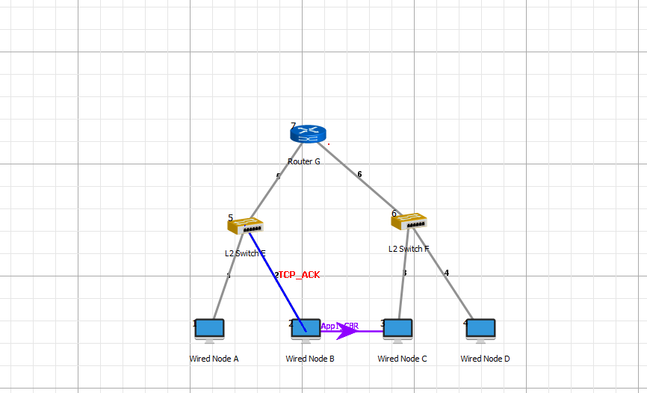

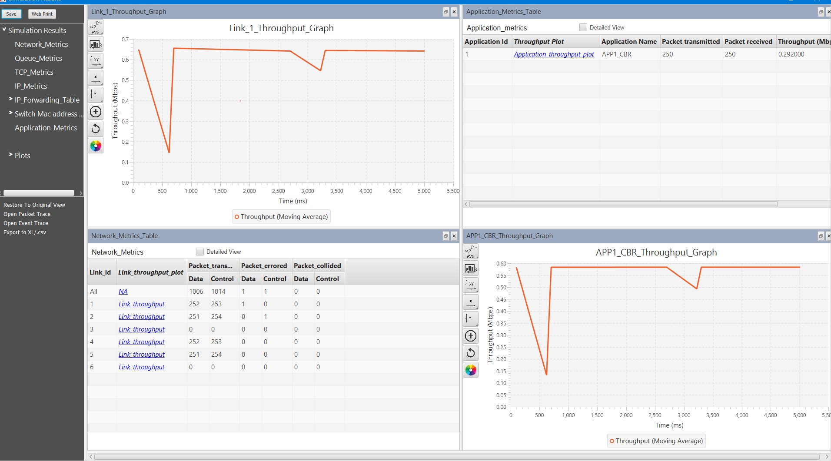

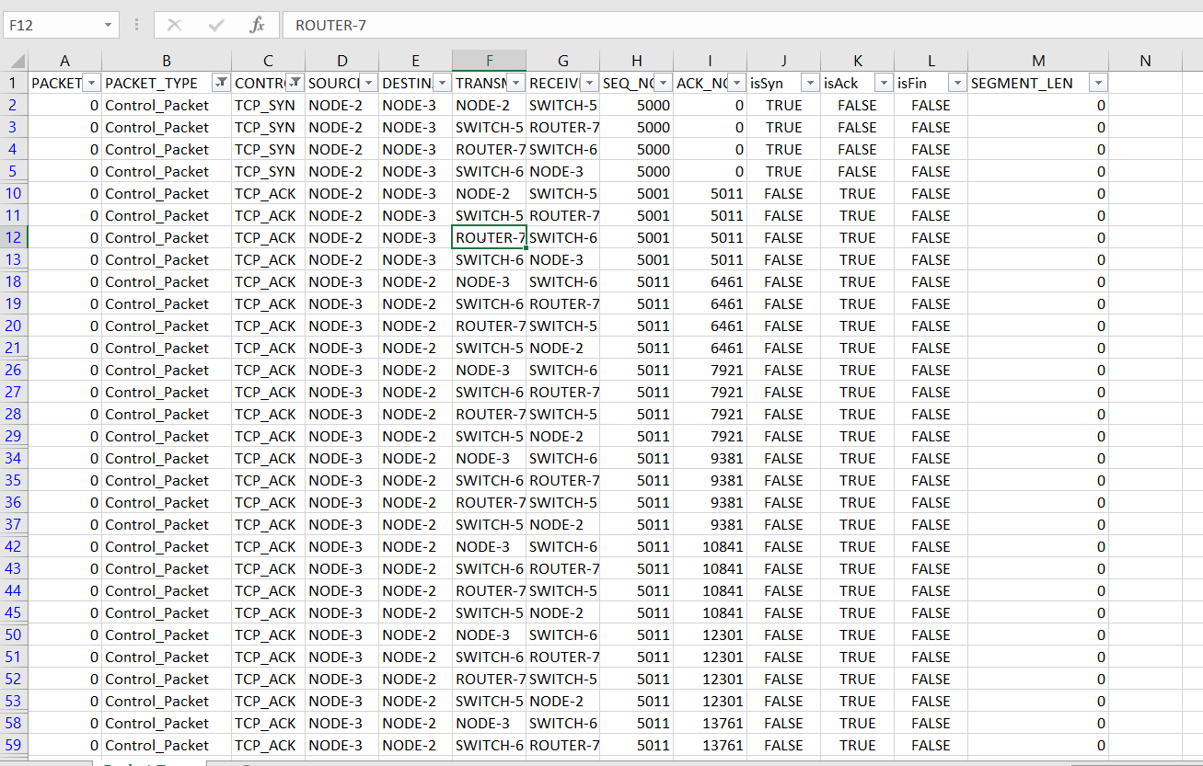

1.What is the Sequence number of the 1st SYN control packet and its acknowledgement?

It is 5000 and isAck is False

2. What is the sequence number of the 1st FIN control packet and its acknowledgement?

It is 5015 and isAck is False

3. Draw the Diagram of Connection establishment and termination as shown in figure 8 and 10 only with sequence number of each packet in you log book..

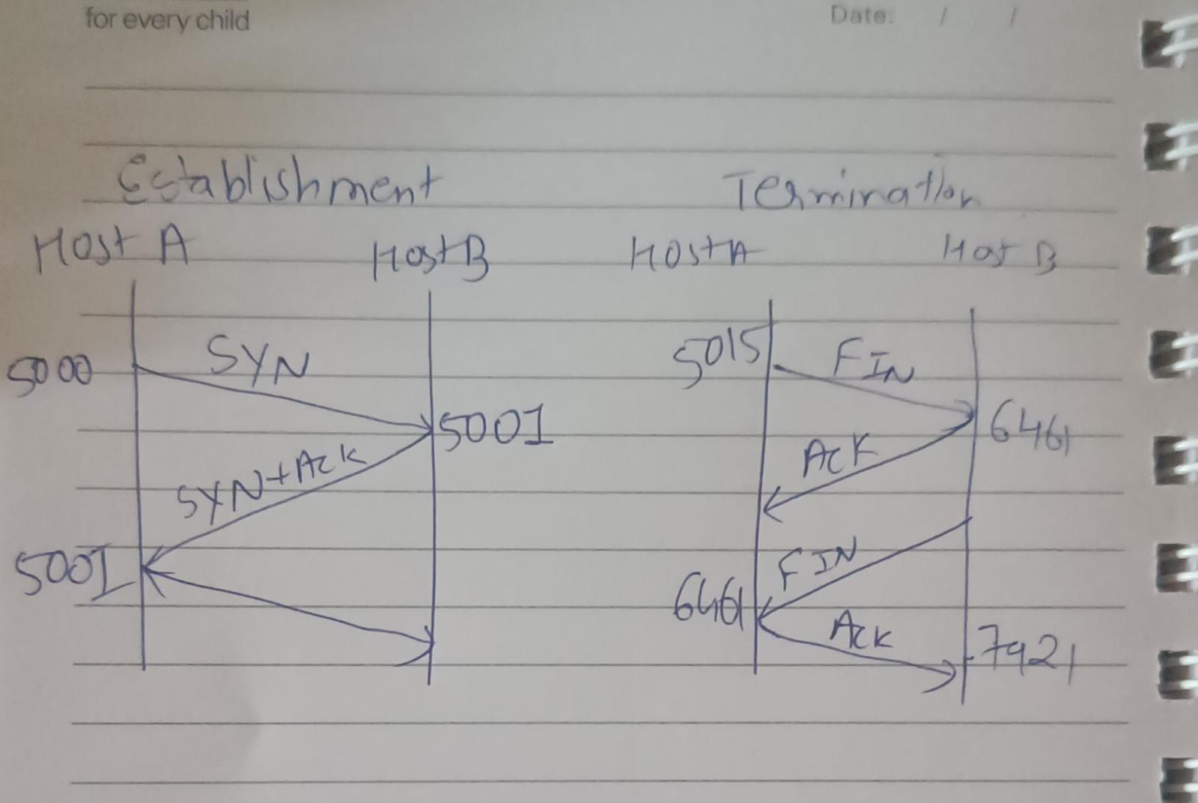

4. Why TCP uses 4 way finishing for connection termination instead of 3way like connection establishment?

In termination both sender and receiver may not want to end connection at same time so they need separate FIN-ACK while in establishment the sender make sure that receiver is ready to connect which can be done in just 3 ways which is justified.

5. How many sessions it takes to transfer all data in this application?

The TRUE value of is SYN is 16 times so in all, total of 4 session is taken.